##### “COACHING MANAGEMENT SYSTEM “

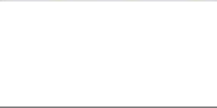

Major Project Report

Submitted in partial fulfillment of the requirements for the Award of degree of Bachelor of Computer Applications

2016-2020

**Submitted by Guided by**

**Vibhor Jain (0161BCA067) Mrs. Gargi Mukherjee**

BHARATI VIDYAPEETH (DEEMED TO BE UNIVERSITY)

INSTITUTE OF MANAGEMENT & RESEARCH, NEW DELHI

A-4, Paschim Vihar, New Rohtak Road, New Delhi-110063





TITLE OF THE PROJECT

##### "Coaching Management System"

**INTRODUCTION**

I have decide to start the project of "**Coaching Management system**" come over in my mind when I saw my cousin brother institute where I see all the jobs is done manually. He maintain all the student data in register. The record of student like batch time ,fees due, batch days ,class, subject are handled manually. If he want to see any due date of fees then all the records will be seen one by one. This is laborious and dull process. The entire work of institute is depending upon only one man. Like search ,update , delete view and add the student information are difficult. Current approach of job is based on manual system in which all the details is first received and then entered in the register. When any new student take admission all the record is stored into the register. The most difficult part is to store the record of fees manually. One thing I will also notes that how he managed the marks of monthly test he taken. He managed the monthly test by writing the name , date , marks , subject, class into the register. This project was made so that coaching work comfortable and responsive. The project will hold the information of the coaching. It come up with provisions remain the record the overall tasks of student in coaching center.

## OBJECTIVES

This project is build on java and RDBMS technology. The main objectives of our work are:

* It will reduce the load work .
* It will save paper work and save time .
* We can find any record easily.
* To change and update record is simple task.
* This system can provide the flexible report.
* It will also reduce Data redundancy**.**
* Centralized database system.
* Data can be share.

##### PROJECT CATEGORY

The project "**Coaching Management System**" is creates under **RDBMS[Relational Database Management System].** The application is progress with the help of Net Beans java and mysql.

**MODULES AND THEIR DESCRIPTION**

* **User Management:-**

This model deals with the management of data stored by maintaining the following details :

* + Storing details of data stored by various independently.
  + Maintaining the details about data .
* **USER REGISTRATER:-**

This model deals with the management of user personal details and user account information.

* + It first verifies and then stores the details of various users permanently for future references.
  + Assignment of a unique login ID i.e. user name and password.
  + This user authentication is made on the basis of the data stored in the user details database.

#### ADMINISTRATOR:-

Administrator performs the administrative activities for the application:-

* + Admin can view the personal details of any registered user.
  + Administrator can delete or modify any category.

## REPORT GENERATION

* Student Details
* Fees Details
* Class Details
* Subject Details
* Time Details
* Batch Day Details

#### Registration table

**DATA MODELING**

|  |  |
| --- | --- |
| **FIELD** | **TYPE** |
| Name | char(20) |
| Address | char(20) |
| Emilid | varchar(20) |
| Phoneno | Int(11) |

|  |  |
| --- | --- |
| Classes | Int(11) |
| Stream | Char(20) |
| Subject | Char(20) |

**Login table**

|  |  |
| --- | --- |
| **FIELD** | **TYPE** |
| user name | Char(20) |
| Password | Char(20) |

TOOLS AND PLATFORM

**Hardware Requirement:**

**Processor**: intel CORE i5

**RAM**: 8GB

**HD**: 1 TB

**Software Requirement: Operating System :** Windows 10 **Database :** Mysql

**Java (NetBeans IDE)**

DATAFLOW DIAGRAM

|  |  |  |
| --- | --- | --- |
|  | **Fees Management** |  |
| VIBHOR JAIN | Page 11 |

**Coaching Management System**

**Class Time Management**

**Login Page Management**

**Student Management**

**Zero Level DFD -Coaching Management System**

VIBHOR JAIN

Page 12

**Generate Fees Report**

**Fees Management**



**Coaching Management**

**System**

**Check user Login Details**

**Login Page Management**

**Generate Class Time Report**

**Class Time Management**

**Generate Student Report**

**Student Management**

**First Level DFD -Coaching Management System**

**Login**

**to System**

**Check**

**Access**

**Admin**

VIBHOR JAIN Page 13

**Manage**

**Modules**

**Manage Timetable**

**Details**

**Manage Fees Details**

**Manage teacher details**

**Manage class Details**

**Second Level DFD -Coaching Management System**

# E-R Diagram

T_NAME

SUBJECT

ROLL NO.

PASSWORD

PHONE NO

VIBHOR JAIN Page 14

ADDRESS

**STUDENT**

T_ID

**TEACHER**

LOGIN NAME

**ADMIN**

NAME

S_ID

teach

CT_ID

give

T_DATE

PASSWORD

TIME

T_MARKS

take

manages

select

S_ID

S_NAME

**SUBJECT**

**CLASS TEST**

**Are you doing this project for any Industry/Client?**

No, I am not doing this project for any industry.

### Interface Design (Screen shots of forms)

##### REGISTRATION FORM

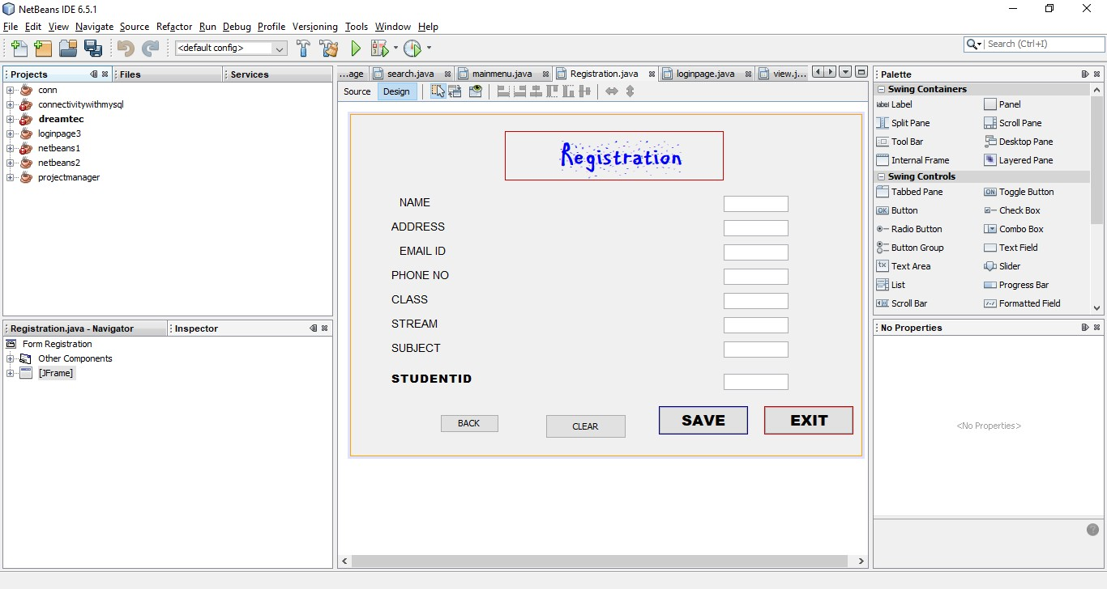

1. login page

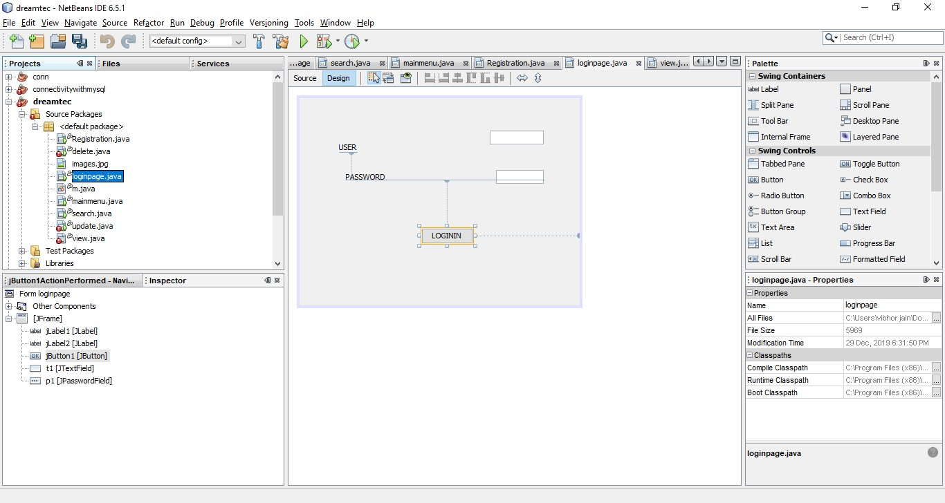

1. main menu

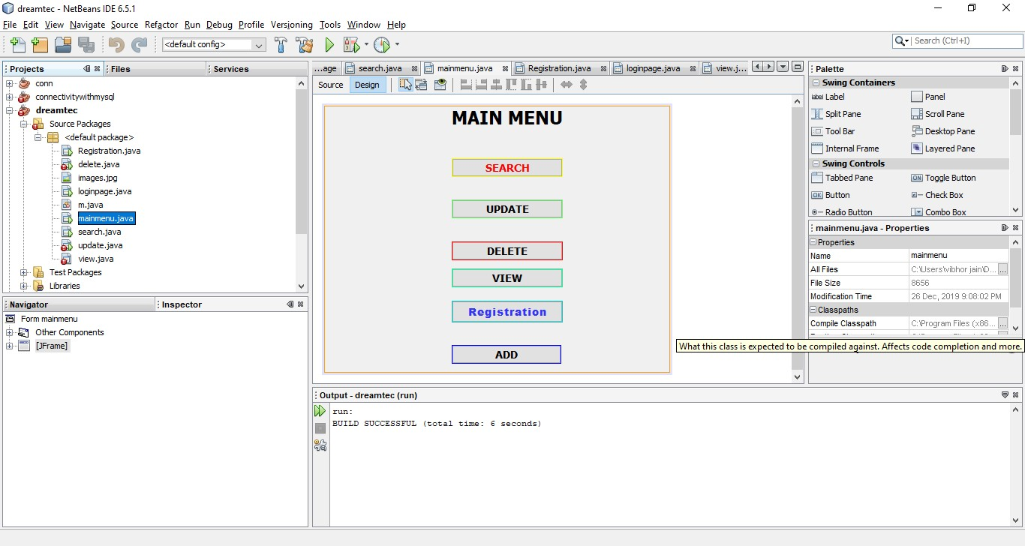

1. search

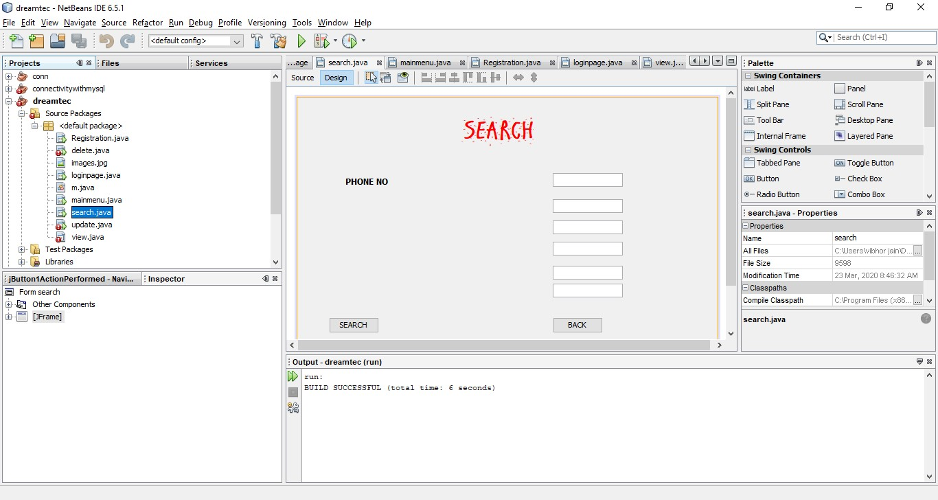

1. delete

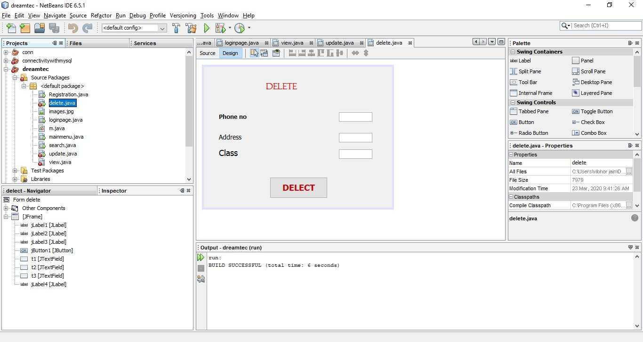

1. update

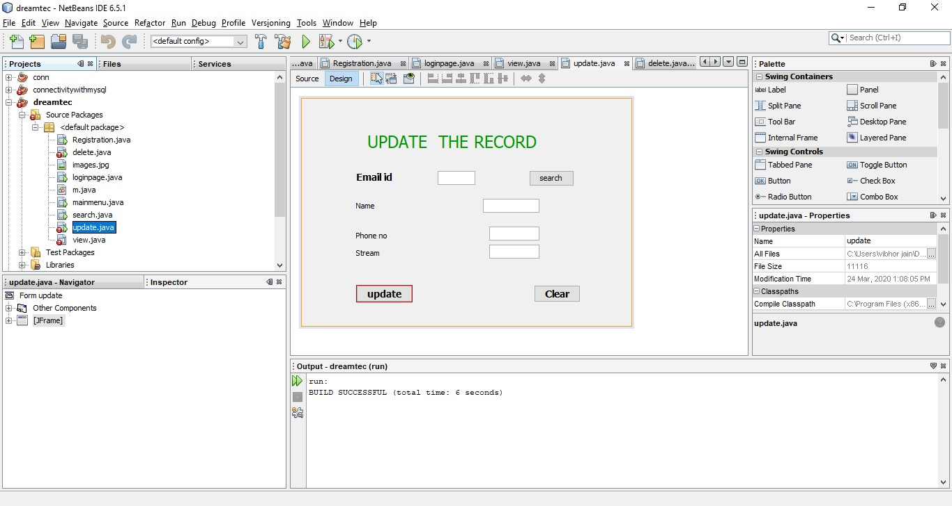

1. view

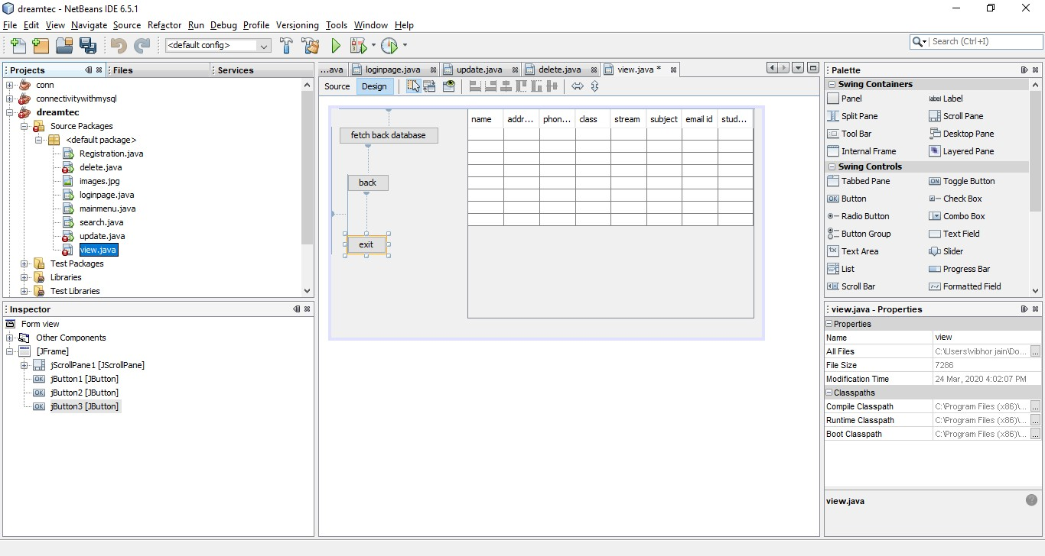

Output Design (Screen Shots of Report)

1. REGISTRATION FORM

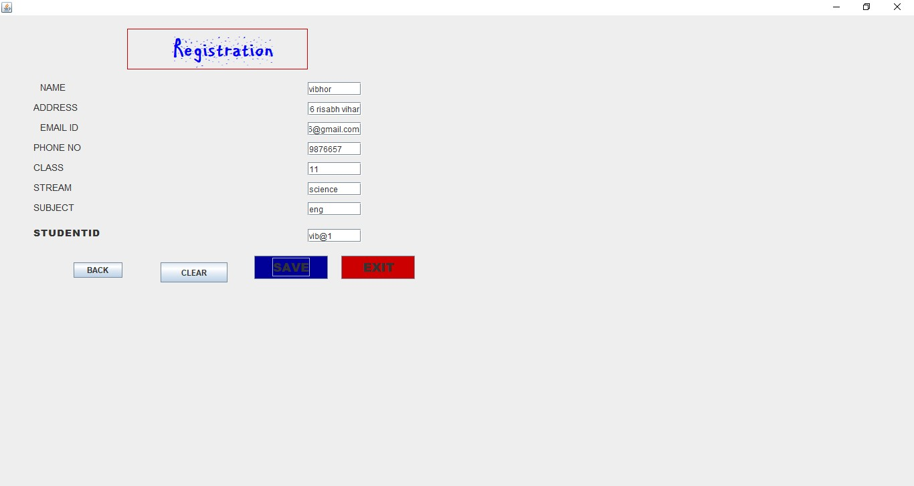

1. login page

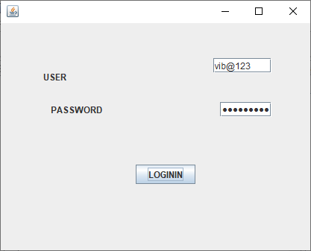

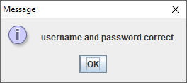

1. main menu

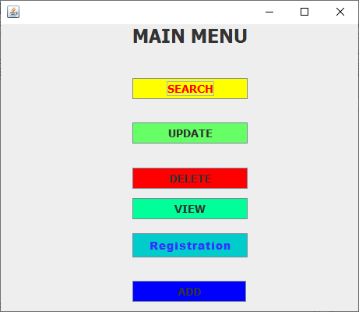

1. search

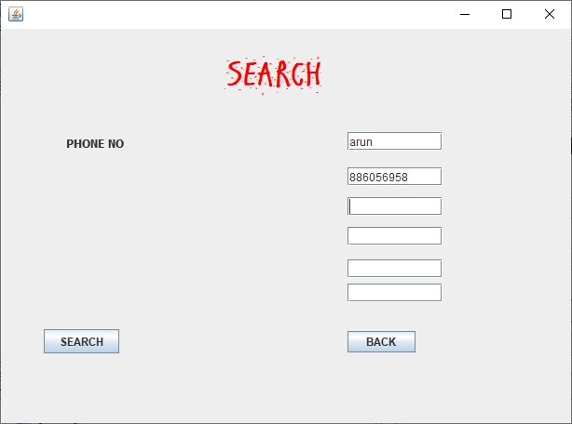

1. delete

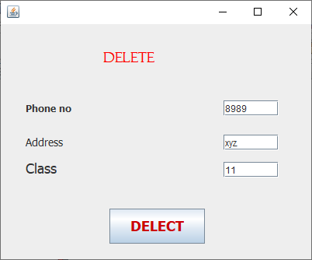

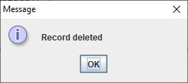

1. update

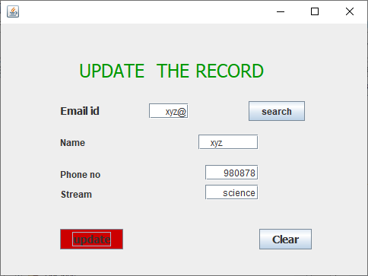

1. view

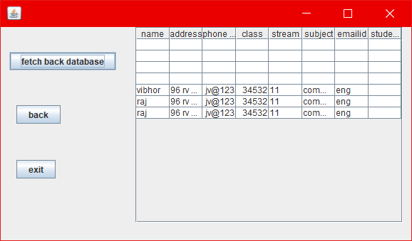

Testing Methodology (Types)

sotware Testing Methodology is defined as strategies and testing types used to certify that the Application Under Test meets client expectations. Test Methodologies include functional and non-functional testing to validate the AUT. Examples of Testing Methodologies are [Unit Testing](https://www.guru99.com/unit-testing-guide.html), [Integration Testing](https://www.guru99.com/integration-testing.html), [System Testing](https://www.guru99.com/system-testing.html), [Performance](https://www.guru99.com/performance-testing.html) [Testing](https://www.guru99.com/performance-testing.html) etc. Each testing methodology has a defined test objective, test strategy, and deliverables.

**Note**: Since Software Testing is an integral part of any Development Methodology, many companies use the term Development Methodologies & Testing Methodologies colloquially. Hence Testing Methodologies could also refer to Waterfall, Agile and other QA models as against the above definition of Testing Methodologies. Discussion on various testing types does not add value to the readers. Hence, we will discuss the different development models.

##### Testing Methodology applied (Why)

Software **Testing Methodology** is defined as strategies and **testing** types used to certify that the Application Under **Test** meets client expectations. **Test Methodologies** include functional and non-functional **testing** to validate the AUT. ...

Each **testing methodology** has a defined **test** objective, **test** strategy, and deliverables.

##### Functional vs. Non-functional Testing

The goal of utilizing numerous testing methodologies in your development process is to make sure your software can successfully operate in multiple environments and across different platforms. These can typically be broken down between functional and non- functional testing. Functional testing involves testing the application against the business requirements. It incorporates all test types designed to guarantee each part of a piece of software behaves as expected by using uses cases provided by the design team or business analyst. These testing methods are usually conducted in order and include:

* Unit testing
* Integration testing
* System testing
* Acceptance testing

Non-functional testing methods incorporate all test types focused on the operational aspects of a piece of software. These include:

* Performance testing
* Security testing
* Usability testing
* Compatibility testing

The key to releasing high quality software that can be easily adopted by your end users is to build a robust [testing framework](https://smartbear.com/learn/automated-testing/test-automation-frameworks/) that implements both functional and non-functional software testing methodologies.

##### Unit Testing

Unit testing is the first level of testing and is often performed by the developers themselves. It is the process of ensuring individual components of a piece of software at the code level are functional and work as they were designed to. Developers in a test-driven environment will typically write and run the tests prior to the software or feature being passed over to the test team. Unit testing can be conducted manually, but automating the process will speed up delivery cycles and expand test coverage. Unit testing will also make debugging easier because finding issues earlier means they take less time to fix than if they were discovered later in the testing process. TestLeft is a tool that allows advanced testers and developers to shift left with the fastest test automation tool embedded in any IDE.

Start Shifting Left and Automate now with **TestLeft**

##### Integration Testing

After each unit is thoroughly tested, it is integrated with other units to create modules or components that are designed to perform specific tasks or activities. These are then tested as group through integration testing to ensure whole segments of an application behave as expected (i.e, the interactions between units are seamless). These tests are often framed by user scenarios, such as logging into an application or opening files. Integrated tests can be conducted by either developers or independent testers and are usually comprised of a combination of automated functional and manual tests.

##### System Testing

System testing is a black box testing method used to evaluate the completed and integrated system, as a whole, to ensure it meets specified requirements. The functionality of the software is tested from end-to-end and is typically conducted by a separate testing team than the development team before the product is pushed into production.

##### Acceptance Testing

Acceptance testing is the last phase of functional testing and is used to assess whether or not the final piece of software is ready for delivery. It involves ensuring that the product is in

compliance with all of the original business criteria and that it meets the end user’s needs. This requires the product be tested both internally and externally, meaning you’ll need to get it into the hands of your end users for beta testing along with those of your QA team. Beta testing is key to getting real feedback from potential customers and can address any final usability concerns.

##### Performance Testing

[Performance testing](https://smartbear.com/learn/performance-testing/what-is-load-testing/) is a non-functional testing technique used to determine how an application will behave under various conditions. The goal is to test its responsiveness and stability in real user situations. Performance testing can be broken down into four types:

* **Load testing** is the process of putting increasing amounts of simulated demand on your software, application, or website to verify whether or not it can handle what it’s designed to handle.
* **Stress testing** takes this a step further and is used to gauge how your software will respond at or beyond its peak load. The goal of stress testing is to overload the application on purpose until it breaks by applying both realistic and unrealistic load scenarios. With stress testing, you’ll be able to find the failure point of your piece of software.
* **Endurance testing,** also known as soak testing, is used to analyze the behavior of an application under a specific amount of simulated load over longer amounts of time. The goal is to understand how your system will behave under sustained use, making it a longer process than load or stress testing (which are designed to end after a few hours). A critical piece of endurance testing is that it helps uncover memory leaks.
* **Spike testing** is a type of load test used to determine how your software will respond to substantially larger bursts of concurrent user or system activity over varying amounts of time. Ideally, this will help you understand what will happen when the load is suddenly and drastically increased.

##### Security Testing

With the rise of cloud-based testing platforms and cyber attacks, there is a growing concern and need for the security of data being used and stored in software. Security testing is a non- functional software testing technique used to determine if the information and data in a system is protected. The goal is to purposefully find loopholes and security risks in the system that could result in unauthorized access to or the loss of information by probing the application for weaknesses. There are multiple types of this testing method, each of which aimed at verifying six basic principles of security:

1. Integrity
2. Confidentiality
3. Authentication
4. Authorization
5. Availability
6. Non-repudiation

##### Usability Testing

Usability testing is a testing method that measures an application’s ease-of-use from the end-user perspective and is often performed during the system or acceptance testing stages. The goal is to determine whether or not the visible design and aesthetics of an application meet the intended workflow for various processes, such as logging into an application. Usability testing is a great way for teams to review separate functions, or the system as a whole, is intuitive to use.

##### Compatibility Testing

Compatibility testing is used to gauge how an application or piece of software will work in different environments. It is used to check that your product is compatible with multiple operating systems, platforms, browsers, or resolution configurations. The goal is to ensure that your software’s functionality is consistently supported across any environment you expect your end users to be using.

##### Testing With TestComplete

[TestComplete](https://smartbear.com/product/testcomplete/overview/) is our robust automated GUI testing tool that excels in compatibility and integration testing. It helps QA teams create and run tests across desktop, mobile, and web applications – enabling testing professionals to speed up delivery cycles and improve software quality. Testcomplete comes with built-in support for various test environments, integrations to performance testing tools, as well as support for developer friendly SCMs, allowing you to seamlessness integrate it into your development process. Using TestComplete will enable you to build a robust testing framework that utilizes the broad spectrum of available software testing methodologies.

##### Test Cases

A **TEST CASE** is a set of conditions or variables under which a tester will determine whether a system under test satisfies requirements or works correctly.

The process of developing test cases can also help find problems in the requirements or design of an application.

##### Test Data

**Test data** is data which has been specifically identified for use in tests, typically of a computer program.

Some data may be used in a confirmatory way, typically to verify that a given set of input to a given function produces some expected result. Other data may be used in order to challenge the ability of the program to respond to unusual, extreme, exceptional, or unexpected input.

Test data may be produced in a focused or systematic way (as is typically the case in domain testing), or by using other, less-focused approaches (as is typically the case in high-volume randomized automated tests). Test data may be produced by the tester, or by a program or function that aids the tester. Test data may be recorded for re-use, or used once and then forgotten.

### Gap Analysis (Planned Vs Achieved)

The need for new products or additions to existing lines may emerge from portfolio analysis, in particular from the use of the Boston Consulting Group [Growth-share](https://en.wikipedia.org/wiki/Growth-share_matrix) [matrix](https://en.wikipedia.org/wiki/Growth-share_matrix)—or the need may emerge from the regular process of following trends in the requirements of consumers. At some point, a gap emerges between what existing products offer and what the consumer demands. The organization must fill that gap to survive and grow.

Gap analysis can identify gaps in the market. Thus, comparing forecast profits to desired profits reveals the *planning gap*. This represents a goal for new activities in general, and new products in particular. The planning gap can be divided into three main elements: usage gap, existing gap, and product gap

##### Rework/ Retest

Retesting is testing of a particular [**bug**](http://tryqa.com/what-is-defect-or-bugs-or-faults-in-software-testing/)after it has been fixed. Usually tester raises the bug when they find it while testing the product or its component. This bug is assigned to a developer and he fixes it. Post fixing the bug is assigned to the tester for its [**verification**](http://tryqa.com/what-is-verification-in-software-testing-or-what-is-software-verification/). This testing is known as retesting.

##### Conclusion

This part incorporates the Conclusion came to in the wake of making the present rendition of the product to meet the framework targets. The correlation is done between the framework that was fabricated and unique prerequisites that were structured toward the start of the venture. It additionally depicts the Future Work that is proposed to be practiced with later forms of the product. As expressed in the presentation the base objective toward the start of this venture was to show the center functionalists in an easy to understand GUI interface. This segment delineate which issues happened during the task. It will portray where the arranging was practical and will likewise give suggestion for comparable or additionally extends. The primary

target of the application is to help software engineering understudies comprehend the nuts and bolts of Java, mysql. By perusing through the application and taking a gander at the code for each graphical translation, understudies ought to have the option to effectively get the implementation. The accompanying outcomes have been accomplished after the finishing the framework andrelate back to the framework's objective.1. Ought to permit software engineering understudies to peruse through the code and application: This is accomplished when clients, i.e., software engineering Ought to permit clients to peruse through various item classifications: This is achieved when the client first runs the application and is coordinated to a landing page that has categories available for all the diverse thing types that can be bought with this web based shopping-cart application. The client can peruse and tap on any classification to see the things recorded for that specific category.3. Ought to permit clients to spare things to the t and furthermore to see point by point data about a specific thing: The clients can add any number of things to the shopping basket from any of 67t he recorded classes by just tapping the coaching symbol at the right-hand corner of every item. students

can see a nitty gritty portrayal of the thing and cost by tapping on the more symbol next o the truck icon.4. Ought to permit clients to look at the things: This is accomplished when clients click the checkout button in the shopping basket. The checkout button vanishes when there are no things in the coaching management system. This suggests students can possibly tap the checkout button when there are items in the coaching management system

##### Limitation of System

The core functionality was reached in the following parts. It is possible to insert a new record of customer, change records and delete records. Further development of the project is possible. It will be interesting to implement more functions in the project.

##### FUTURE SCOPE OF THE PROJECT

This project can be easily apply under different situations. We can attach new futures as we can add new attribute as and when we demand. Long-lasting is possible as and when need in the project. There is flexibility all the modules

REGISTRATION

LOGIN PAGE

SEARCH

Page 34

VIBHOR JAIN



##### References/ Bibliography

<https://www.wikipedia.org/>

tutorialspoint

MENU FLOW DIAGRAM

MAIN MENU

DELETE

UPDATE

VIEW

EXIT

### SHOW TABLES

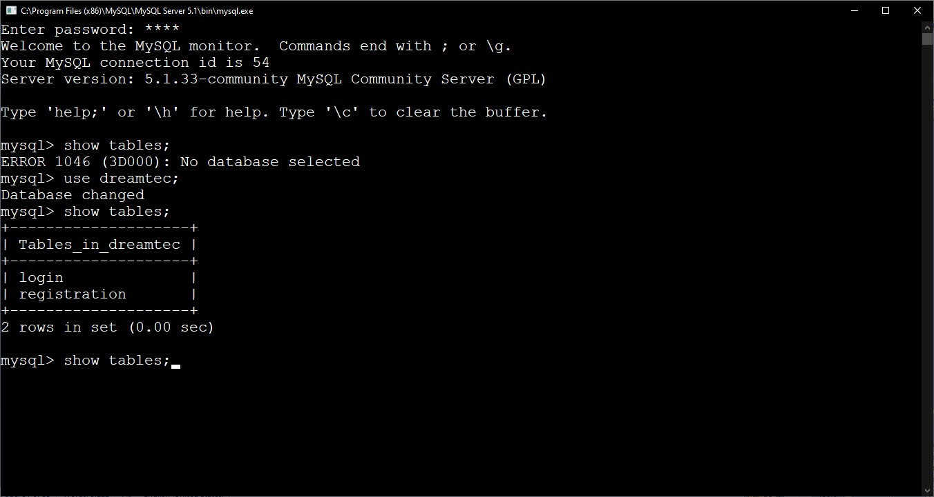

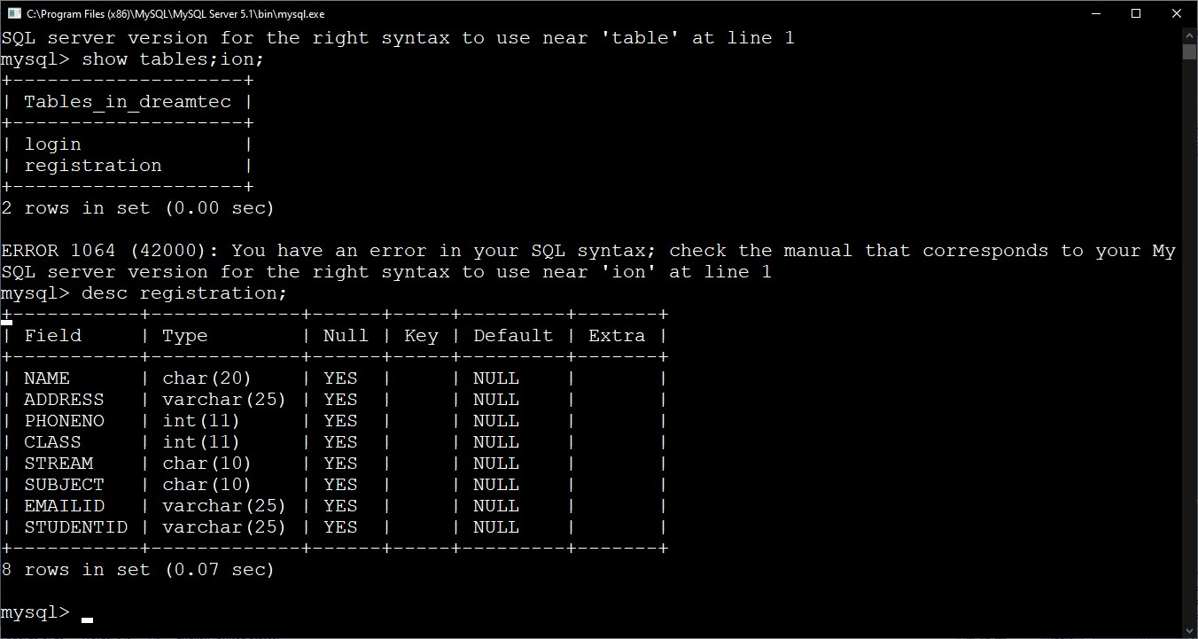

LOGIN TABLE

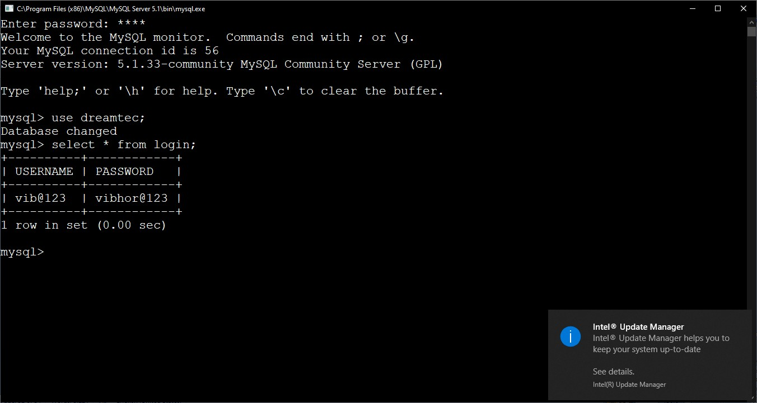

##### Sample Output UPDATE

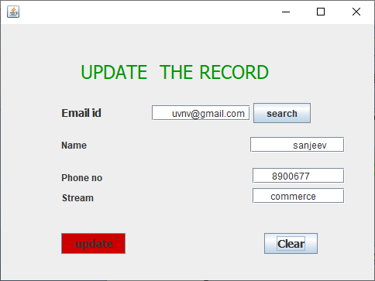

Program Code

REGISTRATION

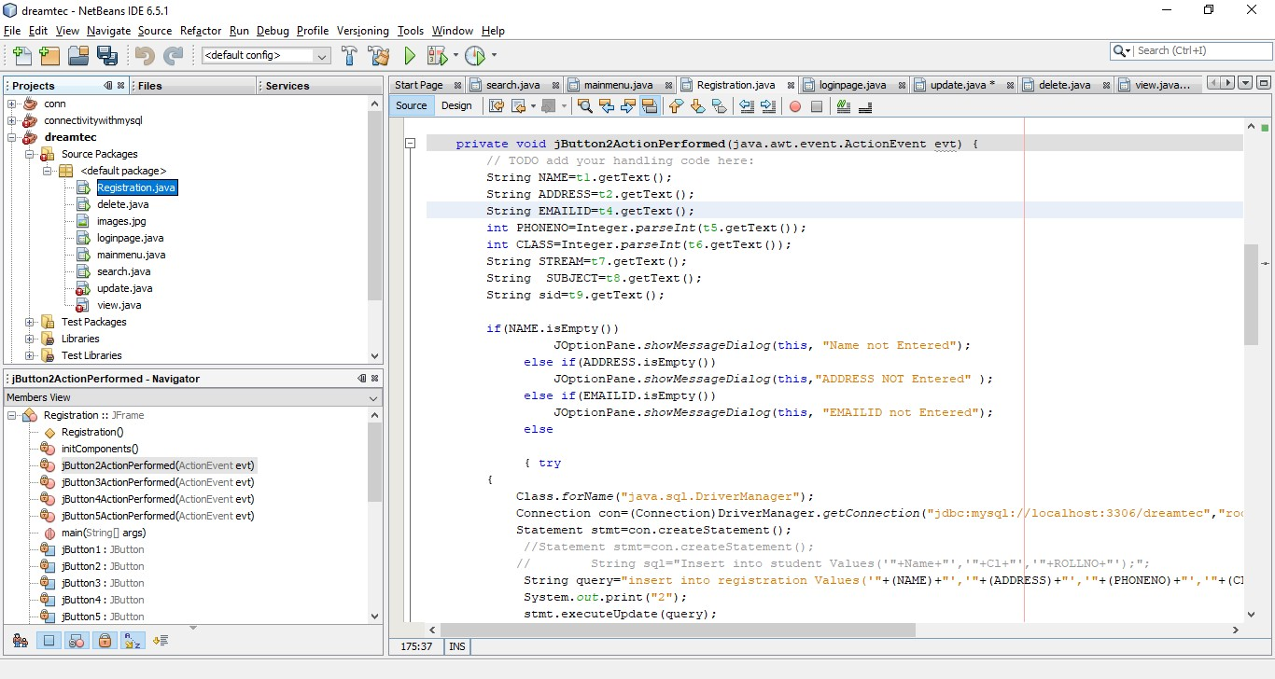



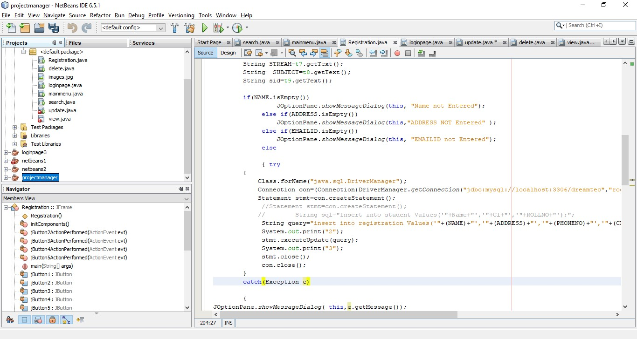

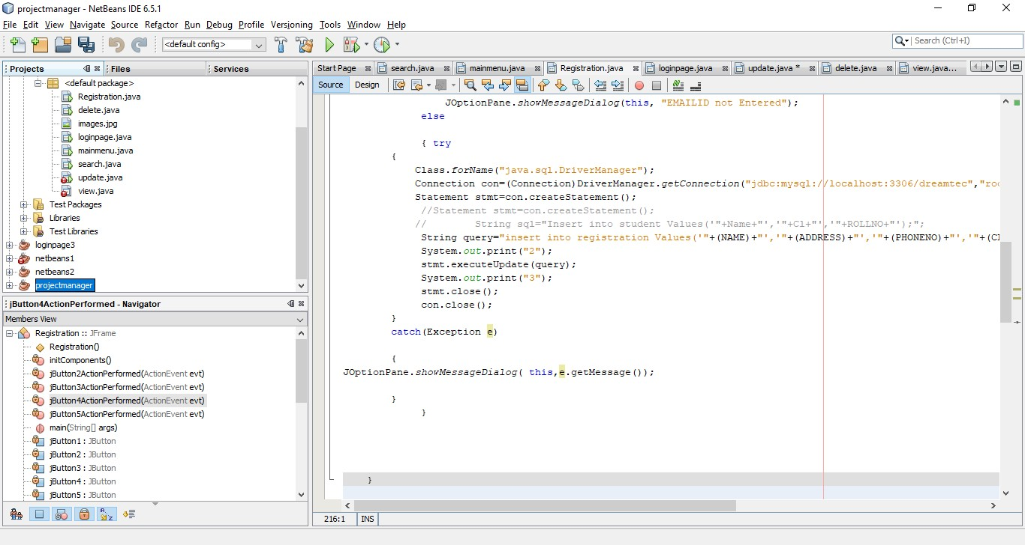

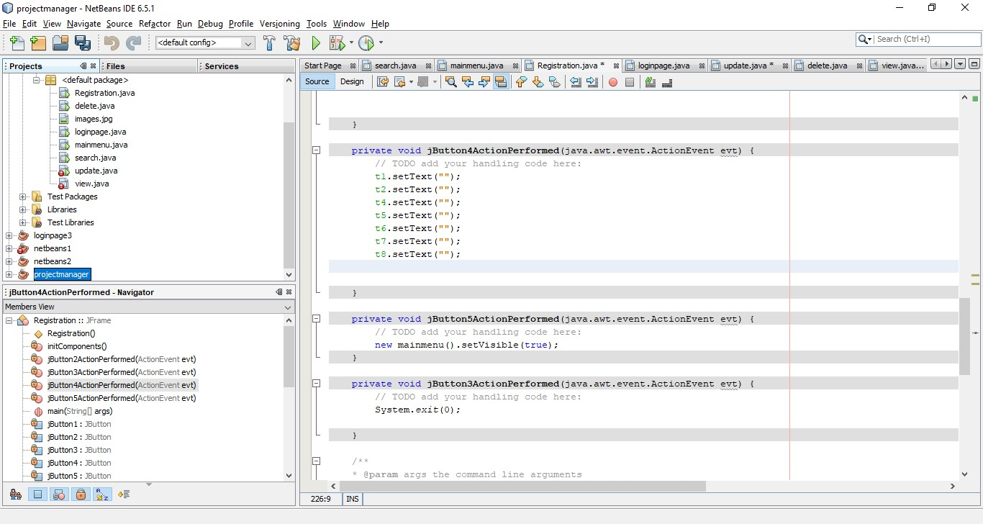

1. MAIN MENU

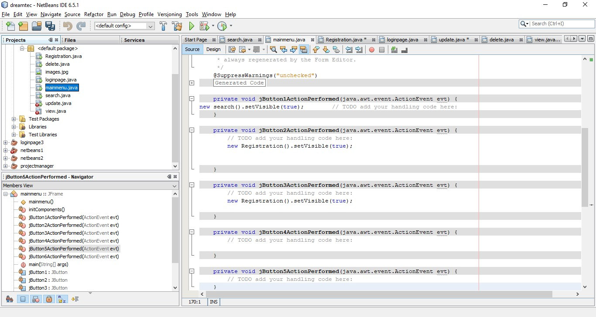

1. LOGIN PAGE



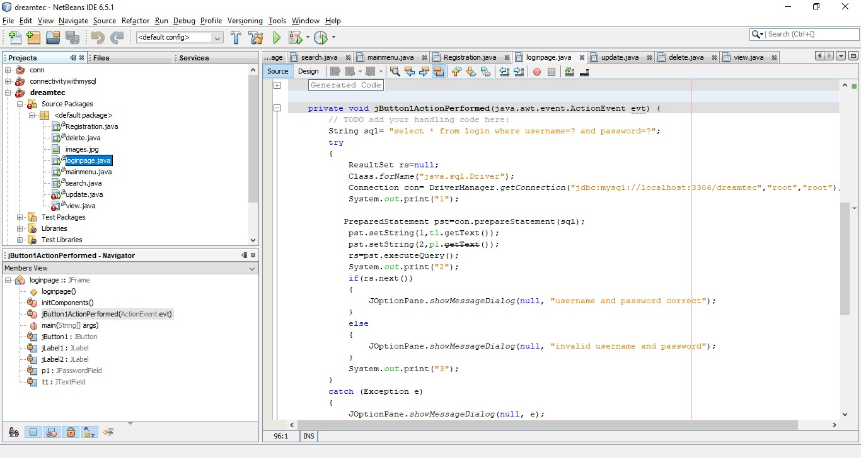

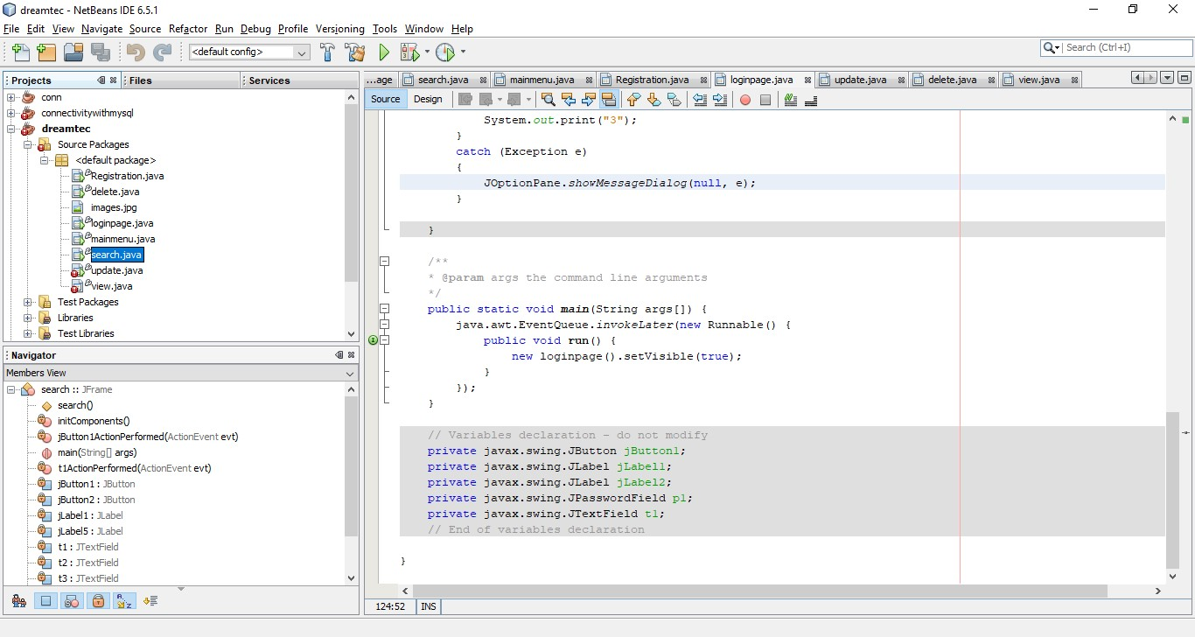

1. SEARCH

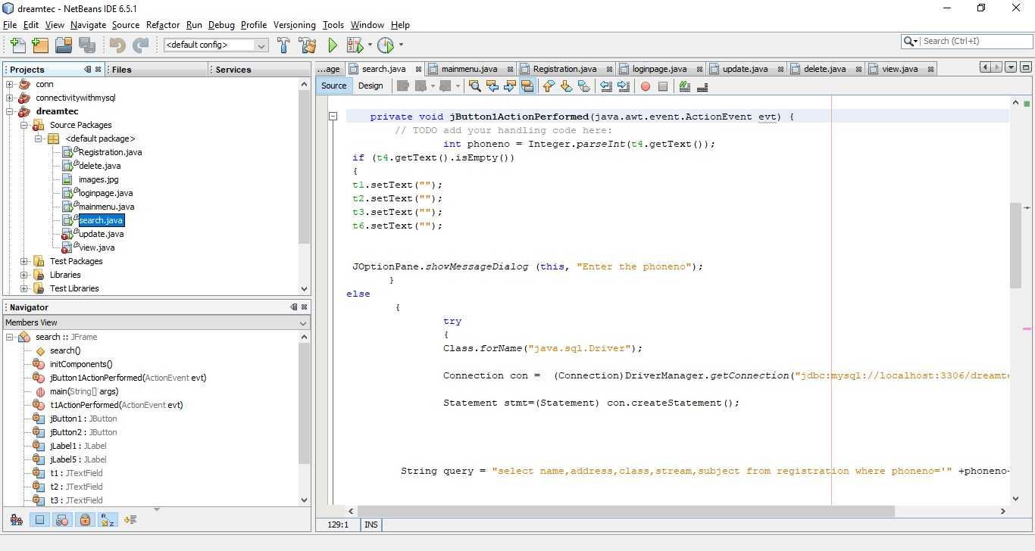



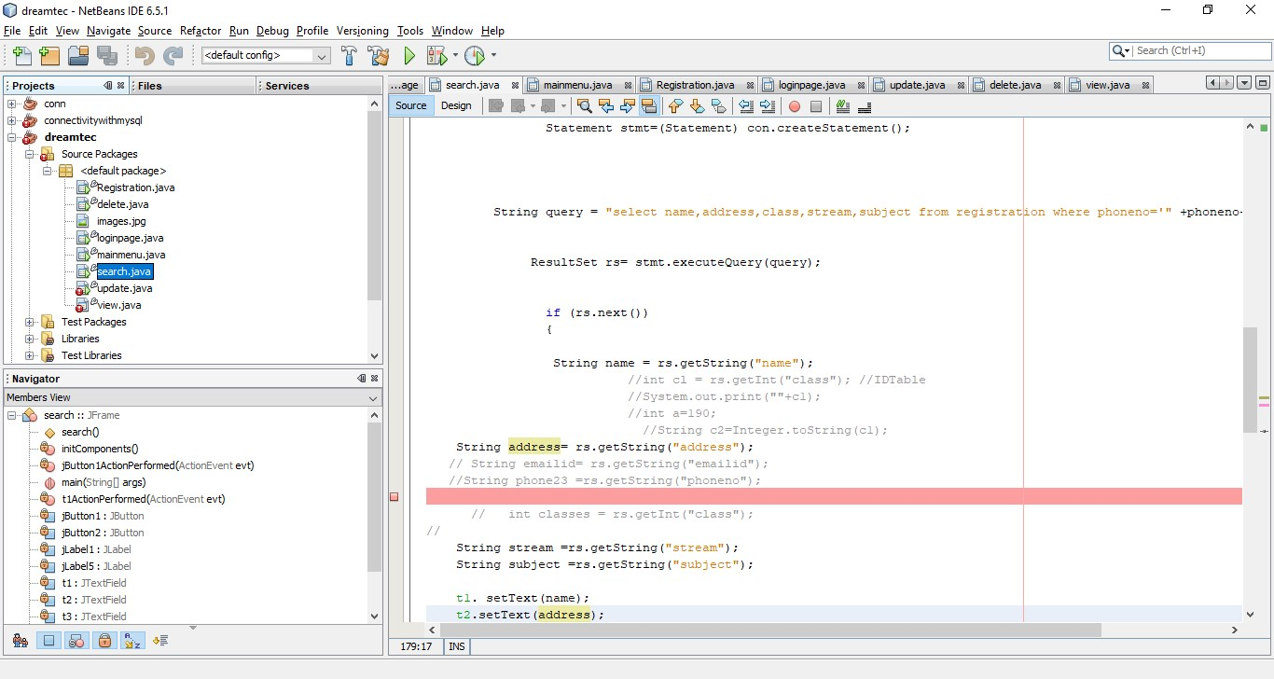

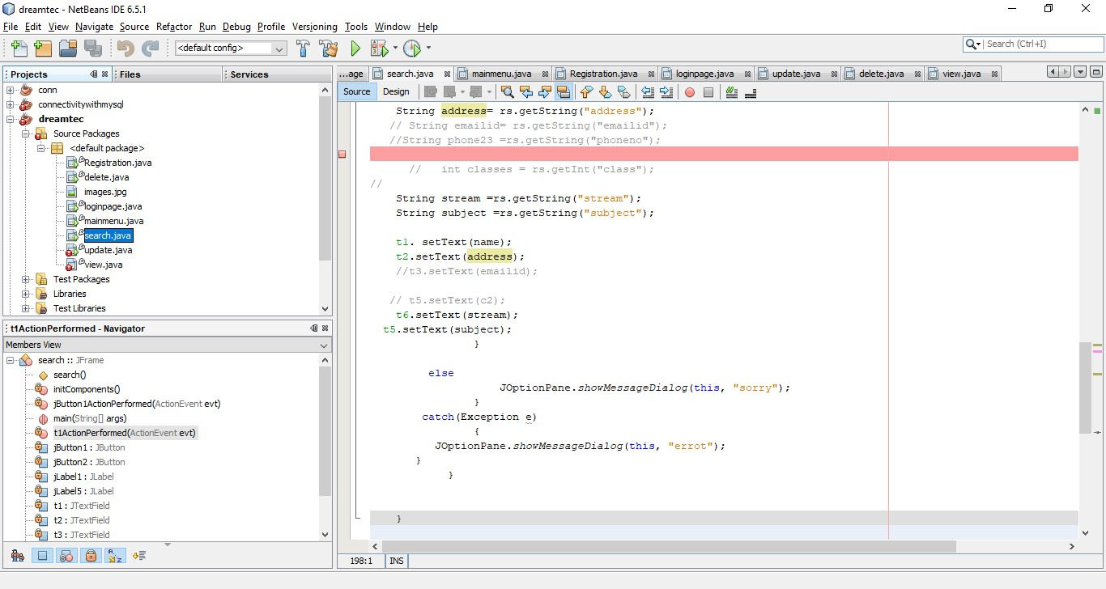

1. DELETE

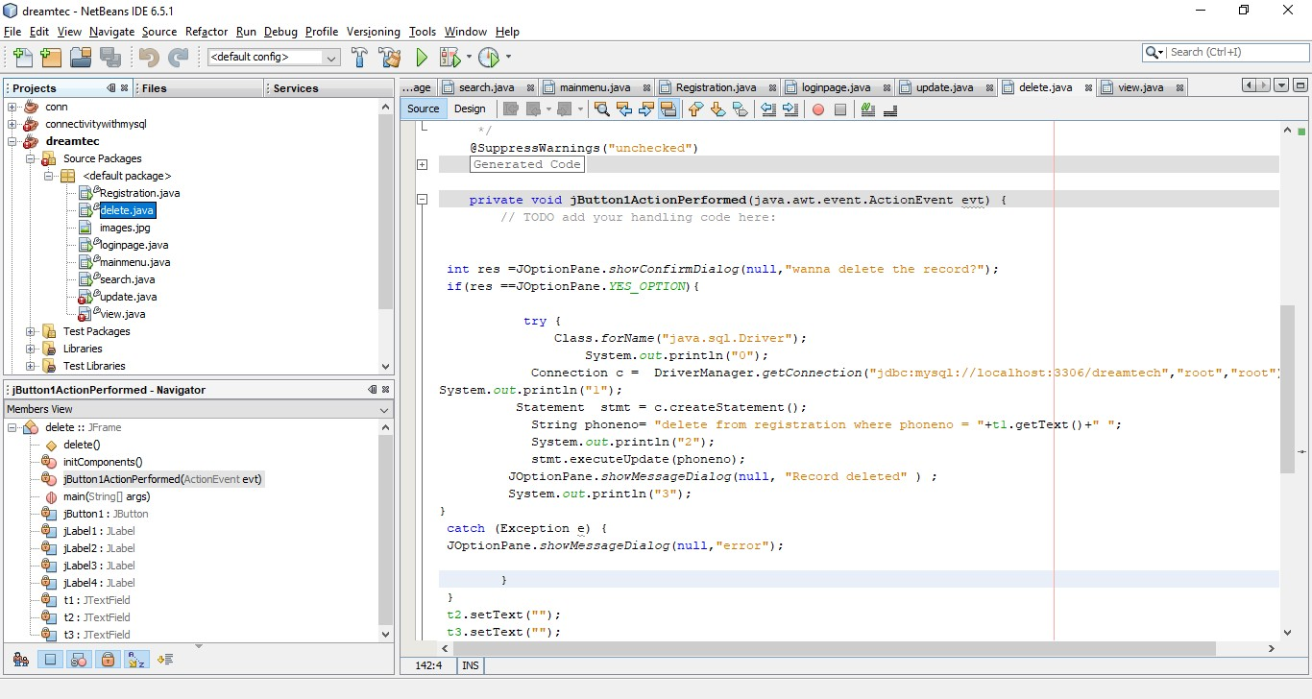

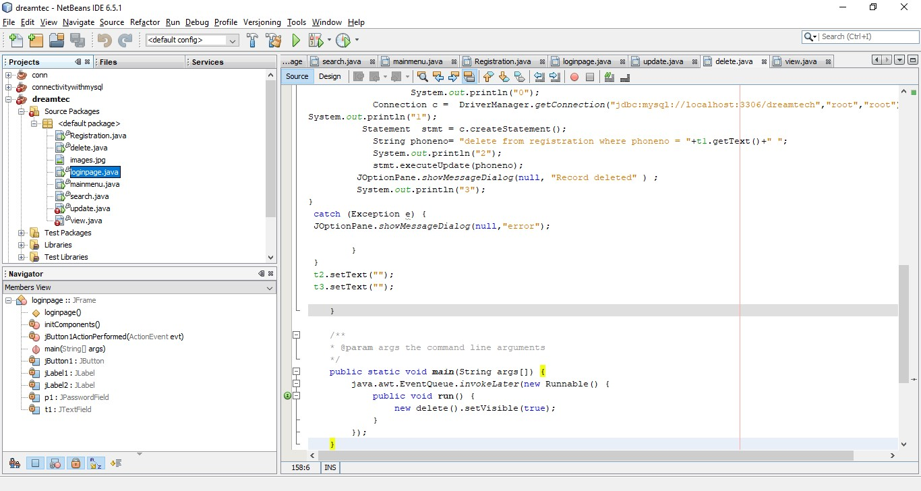

1. UPDATE

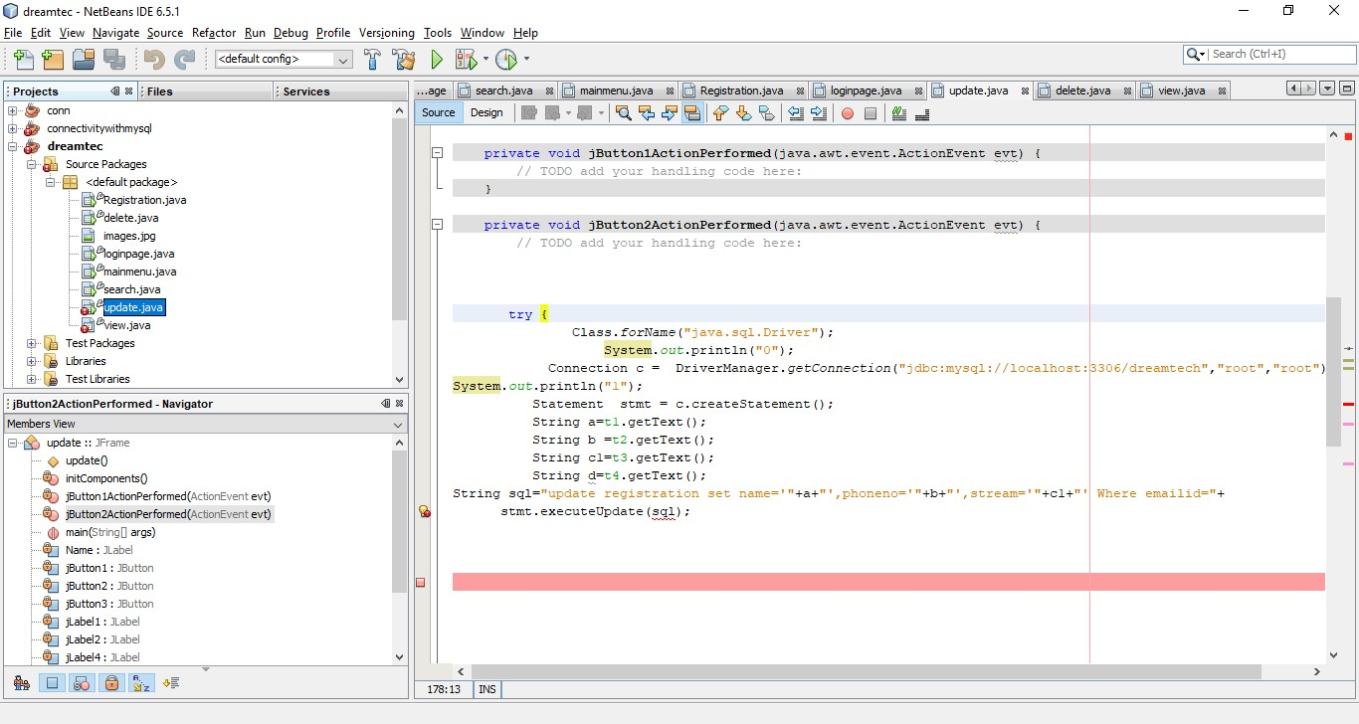

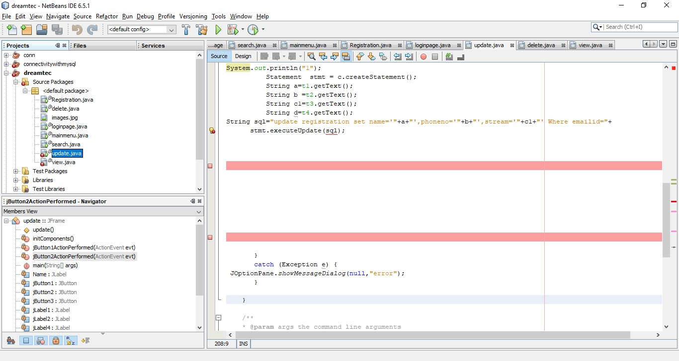

1. VIEW



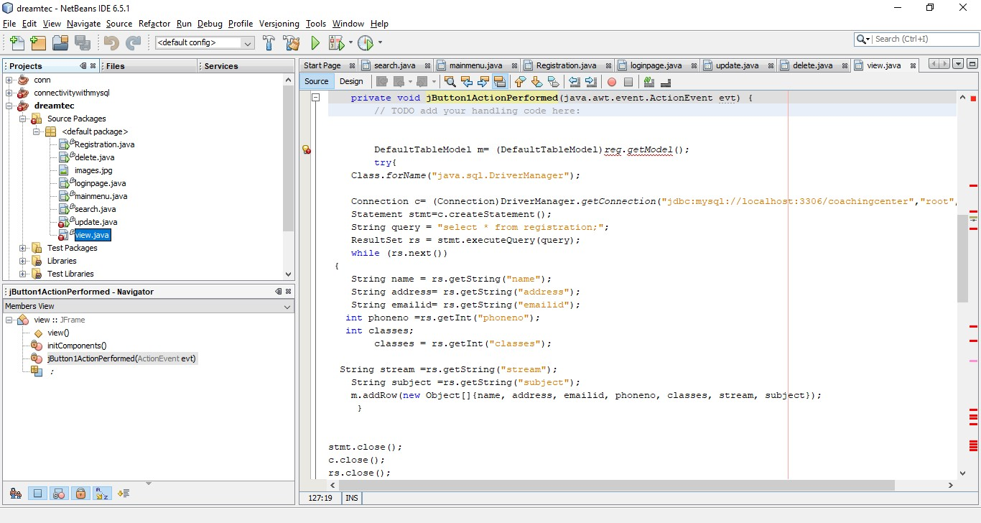

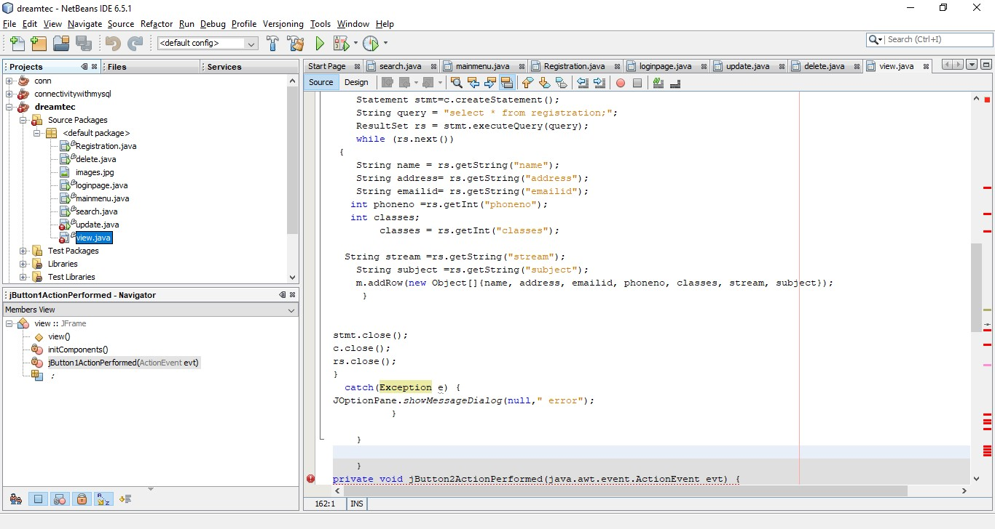

Mentor Feedback Report

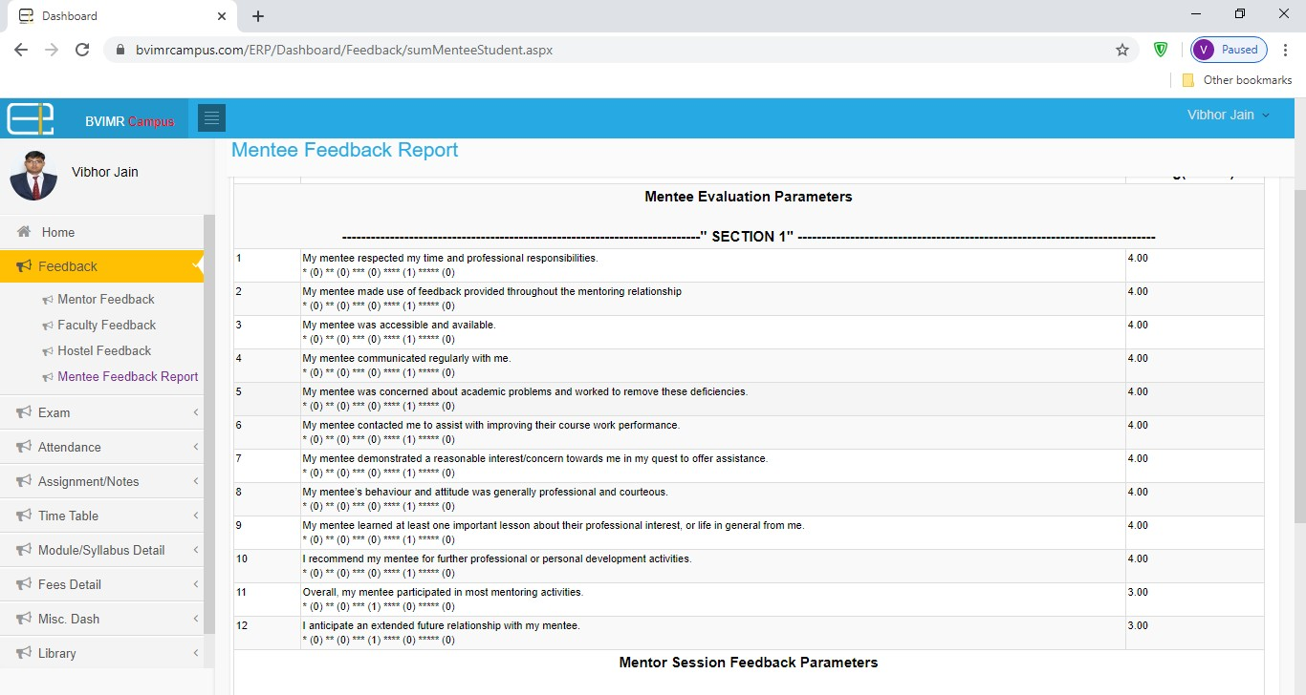

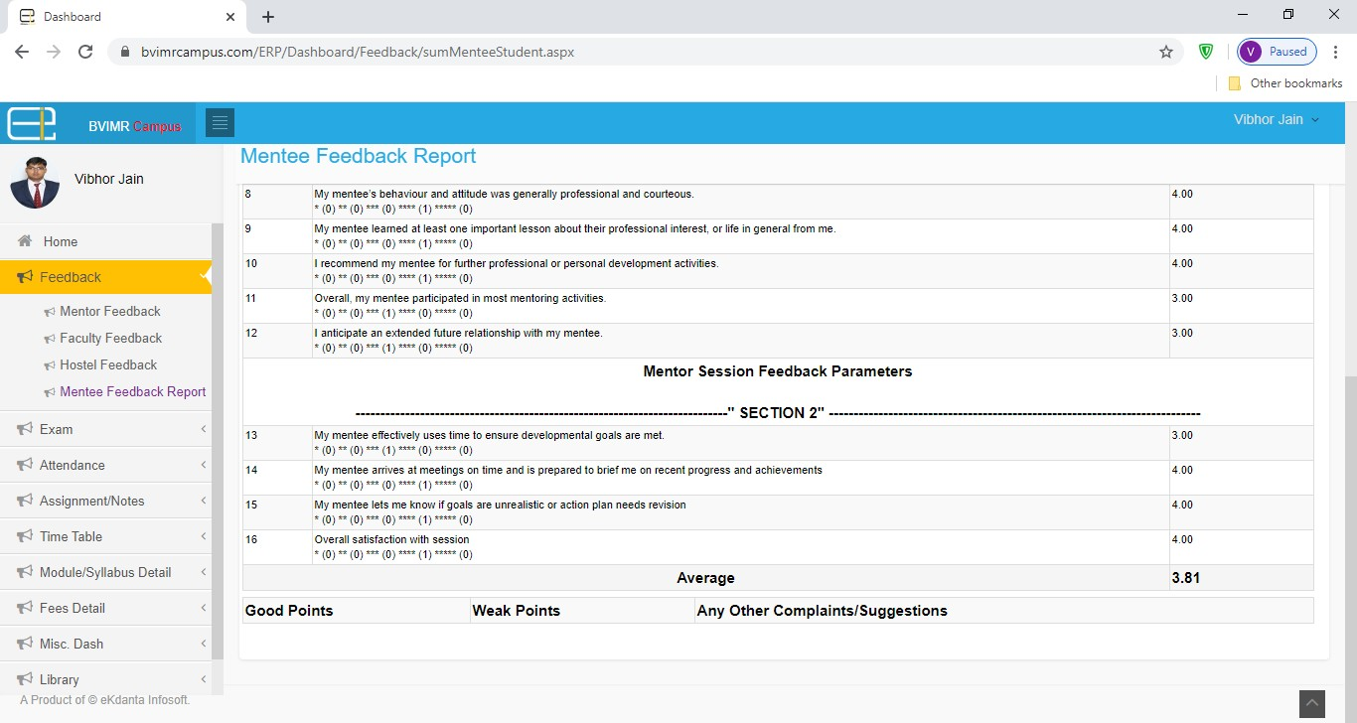

PLAGARISIM REPORT

